Adding Swagger to your code.

Create a project

dotnet new webapi -n Swagger

Add the NuGet package to your project.

cd Swagger

dotnet add package Swashbuckle.AspNetCore

Modify your Program.cs.

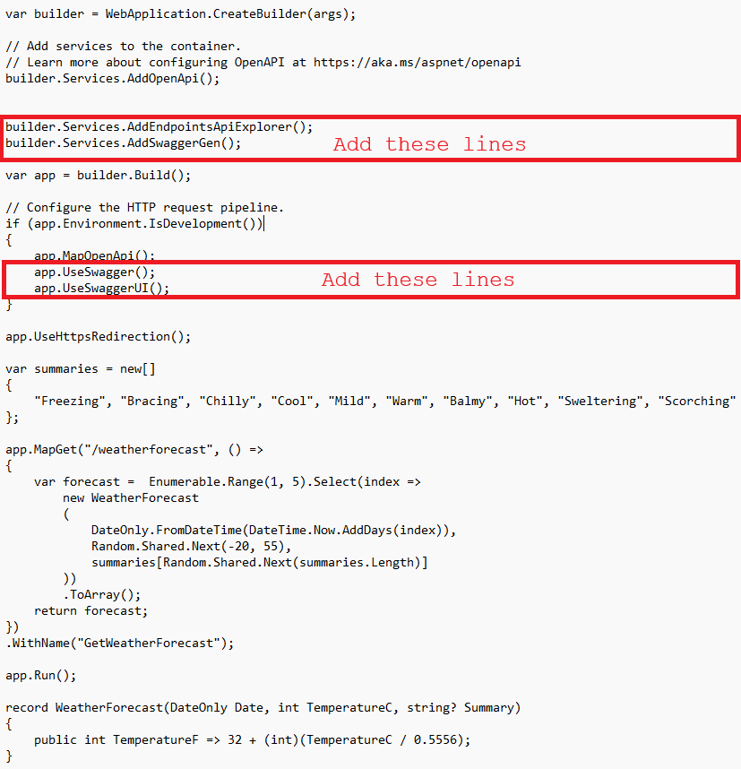

Compile and test.

